Creating accessible Word documents
It is now mandatory for all local authority websites to meet accessibility legislation with regards to any websites and/or apps they produce.
In broad terms, it requires us to meet, as a minimum, Level AA of the Web Content Accessibility Guidelines 2.1
PDF documents are currently the biggest source of inaccessible content on our website. We have a backlog of over 2,000 pdfs on the website to get through, and make accessible.
Our plan is:
- Delete as many PDFs as possible – does it really need to be on the website?
- Audit any PDF forms that we have left and turn them into digital forms
- Make the remaining PDFs accessible using tools in Acrobat
Any new pdf documents that we add to the site have to meet the criteria straight away – there is no grace period.
How can you help us?
Most of the PDF documents on our website start out as internally produced Word documents. There are things you can do when you create your Word documents that make them as accessible as possible, and it’s good practice to do this.
Here is a guide to making your Word documents as accessible as possible.
Language
For screen readers and other assistive technologies to correctly read the document, it must have an overall language designated. If lines or blocks of text within the document change language, then this text must be tagged separately. You can define the language of your Word document in the options menu. In most cases, you will be able to see the selected document language at the bottom of the window.
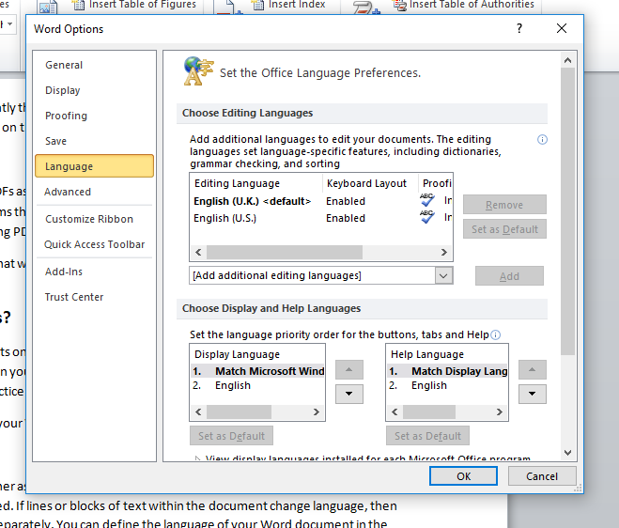

Document information
Title/Author/Keywords
As a minimum, documents should include basic information like a title. It is also a good idea to provide the name of the author, a description, and a few relevant key words. This information can be added in the File menu under Info.
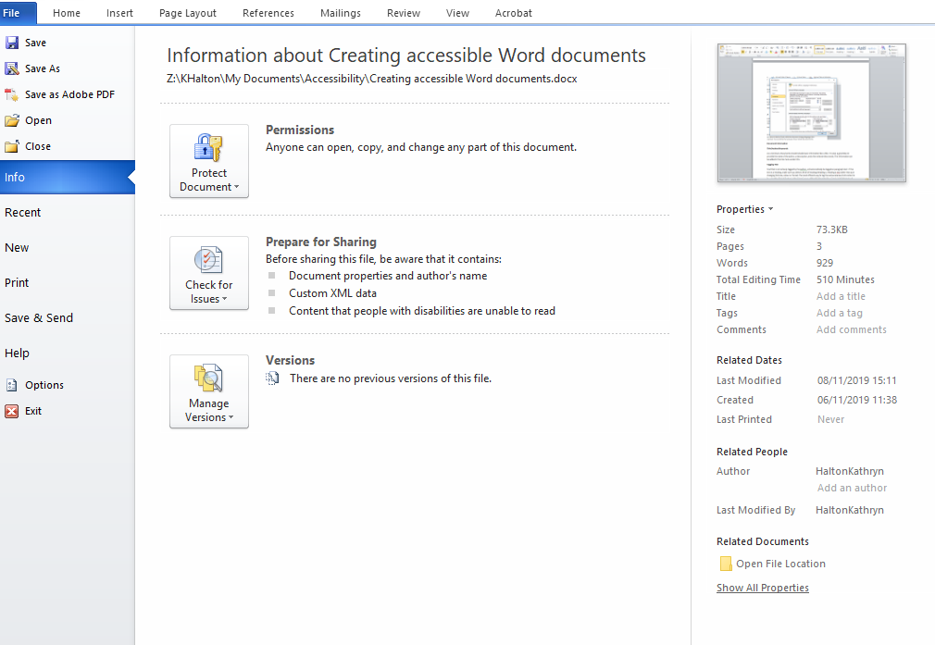
Tagging Text
Text that is not actively tagged by the author, will automatically be tagged as paragraph text. If the text is a heading, make sure you select a level of heading (Heading 1, Heading 2 etc) rather than just changing font size, colour or format. The most efficient way to tag the various elements of content is by using the ‘Styles’ feature in the ‘Home’ menu of the MS Word toolbar. Simply highlight text and select the style needed to tag each section appropriately. After structuring your content, you can then change the font types and colours of these headings by modifying the heading style within the ‘Styles’ menu. This clarifies the document by providing the right tagging for assistive technologies to use.
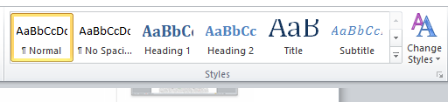

Tables
When you use tables, it’s important that they are only used for data and not layout, and that you tag their structure.
As a minimum, you need to define which the column headings are and which the row headings are. Label the top row as column headings. Then, in table properties, use the setting ‘Repeat as header row at the top of each page’ to tag these table headings, making them recognisable for screen readers and other assistive technologies. Keep your tables as simple as possible, and try not to merge rows and columns, as this complicates navigation for assistive technology users.
Images
An image can have different purposes depending on how it is used in the document. All images must have ‘alternative text’ to describe them. Some images will be purely decorative and should have alt text that describes them as such. Other images may have some sort of function or convey important information, and these images need to have alt text that describes what those images show. Right click the image, and choose ‘Format Picture.’ You can add a title and description of the image in the ‘Alt text’ tab. If the image is purely decorative, either leave the description blank, or put two sets of quotation marks in the box “”.
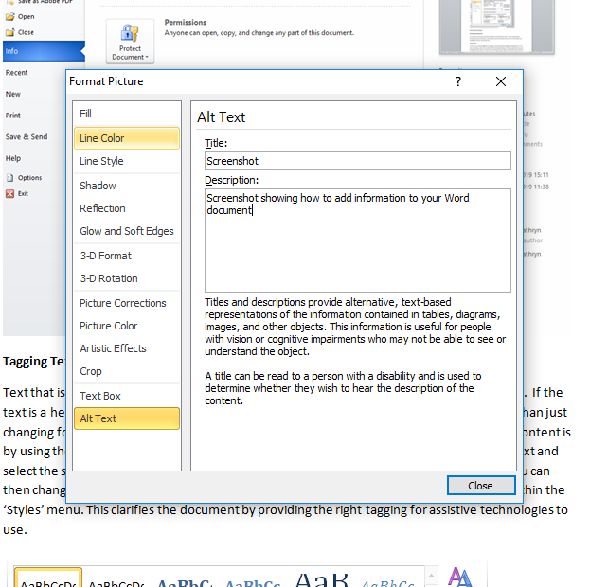
Columns
If you want to present information in Columns, you need to use the built-in Columns feature most often available directly through the top menu. Don’t use the tab key to move content into a position that looks like columns. This method makes the reading order very poor for assistive technologies.
Reading Order
Assistive technologies rely on logical reading sequences to present content to users. When you create a document, it’s important to make sure there is a sensible reading order. Usually, Word documents have a logical structure. Examples of where this sometimes doesn’t happen, are, for example, leaflets which are designed for print, and so have the back page first etc. because they are meant to be folded.
Table of Contents
As long as you have correctly applied header styles to your content, you can automatically create a Table of Contents for larger documents.
Just put your cursor where you want your contents to appear, then go to References and Table of Contents and choose an automatic style.
If you make changes to your document after you have created the table of contents, you can right-click the table of contents and choose Update Field.
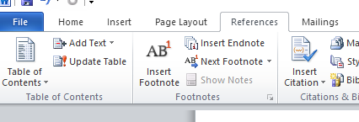
Bookmarks
If a PDF has 21 or more pages, then it has to have bookmarks based on document headings. If you are saving a Word document as a PDF, then you can tick the Bookmarks box in the Options menu when you save the document. Choose the option which says ‘Convert Word headings to Bookmarks.’ This gives users the ability to navigate the pdf using bookmarked headings, rather than having to read through the entire documents to find what they need.

